<http://www.icooc.com/service/oxford/search/?word=a>

**一间自己的房间** yijian516619

# **Oxford Advanced Learner's Dictionary**

<https://zhuanlan.zhihu.com/p/349999554>

A /ei/ noun,symbol,abbr.

* noun(also a)plural As, A's, a's

used to represent a person, for example in an imagined situation or to hide

1. [C,U]the first letter of the English alphabet.‘Apple’ begins with (an) A.
2. [C,U](music)the 6th note in the scale of C major
3. [C,U]the highest mark/grade that a student can get for a piece of work or course of study:She got (an) A in/for biology.

He had straight A's (=nothing but A's) all through high school.

1. used to represent the first of two or more possibilities:Shall we go for plan A or plan B?

see also **[A-frame](http://www.icooc.com/service/oxford/search/?text=a-frame" \o "A-frame definition)**, **[A level](http://www.icooc.com/service/oxford/search/?text=a-level" \o "A level definition)**, **[A-road](http://www.icooc.com/service/oxford/search/?text=a-road" \o "A-road definition)**

**IDIOMS**

#### **from A to B**

from one place to another

*For me a car is just a means of getting from A to B.*

#### **from A to Z**

including everything there is to know about something

*He knew his subject from A to Z.*

* Symbol

1. (in Britain) a road that is less important than a motorway , but wider and straighter than a B-road

the A27 to the town

the A34 to the Newbury

1. used (but not in the US) before numbers which show standard metric sizes of paper

a sheet of A4 paper (= 297×210mm)  
一张A4号纸（= 297 × 210毫米）  
A3 (= 420×297mm)  
A3号纸（= 420 × 297毫米）  
A5 (= 210×148mm)  
A5号纸（= 210 × 148毫米）

* Abbr.in writing以书面形式（尤指作为同意或申诉证明）;

2014托福词汇辨析：a和an的正确用法 来源无忧考网：https://www.51test.net 原文网址：https://www.51test.net/show/4594282.html

****N-COUNT**** ****可数名词****

英语词汇书上的pl是单词plural的缩写 ，是指通常情况下使用单词的复数形式,其实就是复数的缩写。

在牛津字典中plural有两个词性：

名词（noun）：（名词或动词的）复数，复数形式 ；

形容词（adj.）：复数的；复数形式的 ；多样的；多元的；

**字母表中的字母A**

**Letter A in the Alphabet**

发音pronunciation：[eɪ]，类似汉字“诶”第四声[èi]的发音。

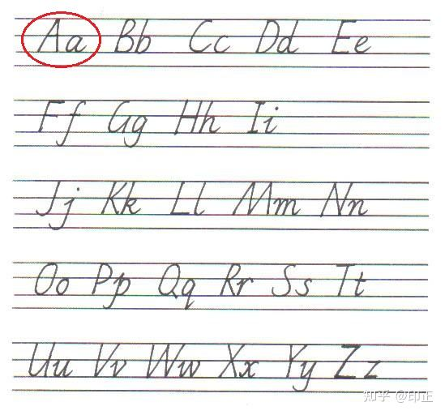英语字母表的第1个字母 the first letter of the English alphabet

1、A

英语字母表的第1个字母 the first letter of the English alphabet

‘Apple’ begins with (an) A.  
apple一词以字母a开头。

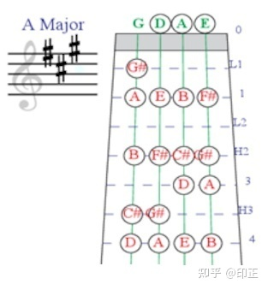A大调 A Major

2、A

A音 C大调的第6音或音符 the 6th note in the scale of C major

This song is in Key A.  
这首歌唱A调。

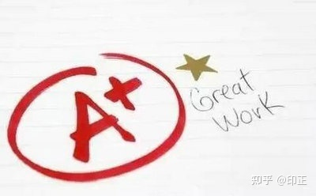A加 A plus

3、A

（学业成绩）第一等，优，甲  
the highest mark/grade that a student can get for a piece of work or course of study

Marry got (an) A in/for History.  
玛丽的历史成绩得A。  
Peter had straight A's all through high school.  
彼得读中学时成绩全部是A。

4、A

（表示两个或两个以上可能性中的）第一个  
used to represent the first of two or more possibilities

They didn't go for plan A or plan B.  
他们不赞成A计划或B计划。

5、A

（代表一个假设的或不指名的人）甲，甲某  
used to represent a person, for example in an imagined situation or to hide their identity

They didn't know A or B is guilty.  
他们不知道甲或乙应负罪责。

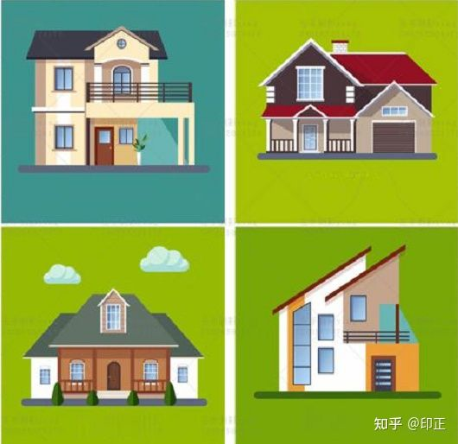A形房屋 A-frame house

6、A-frame

A形房屋 a house with very steep sides that meet at the top in the shape of the letter A

Mike pointed to an A-frame house that looked small and modest in the midst of all that glory.  
麦克指向一座A字构架的屋子，在周围壮观的景象的之下，这座房子显得矮小而又简陋。

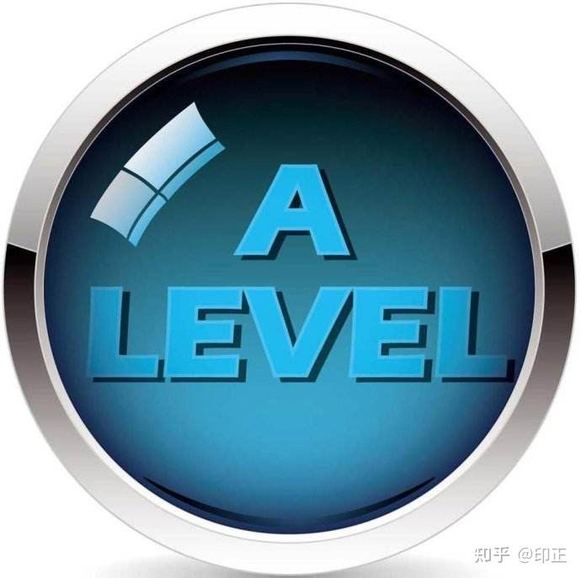高级证书考试 advanced level

7、A level

高级证书考试（英国中学单科考试，通常在毕业年级进行）  
a British exam taken in a particular subject, usually in the final year of school at the age of 18

Jim needs 5 A levels to get onto this university course.  
吉姆要参加这个大学教程，就需要通过5科高级证书考试。  
What A levels are they doing?  
他们在准备哪些科目的高级证书考试？  
They're doing Science A level.  
我在准备自然科学高级证书考试。

8、A-road

A级公路（略次于高速公路，但较B级公路宽直），干线公路（英国公路代号，后接数字）  
(in Britain) a road that is less important than a motorway , but wider and straighter than a B-road

the A27 to the town  
通往城里的A27号（干线）公路

9、（除美国外，用于数字前表示标准纸张尺寸）A…号纸

used (but not in the US) before numbers which show standard metric sizes of paper

a sheet of A4 paper (= 297×210mm)  
一张A4号纸（= 297 × 210毫米）  
A3 (= 420×297mm)  
A3号纸（= 420 × 297毫米）  
A5 (= 210×148mm)  
A5号纸（= 210 × 148毫米）

10、from A to B

从一地到另一地 from one place to another

For him a bike is just a means of getting from A to B.  
在他看来，自行车只不过是从一地到另一地的代步工具。

11、from A to Z

从头到尾；彻底地；完全 including everything there is to know about sth.

Tiger knew Chinese from A to Z.  
泰格通晓汉语。

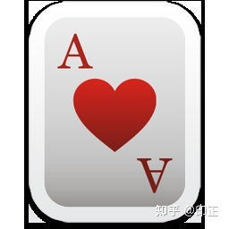红桃A：Ace Of Hearts

12、Heart A

红桃A：Ace Of Hearts

13、A货

1）在外贸行业，是仿冒产品的统称，通常为服装皮包鞋等用品。

In the foreign trade industry, is a generic term for counterfeit products, usually for clothing, leather bags, shoes and other supplies.

2）A品是出售前的正品，A品一旦在正规销售渠道上市，就是正品。

A product is the original product before sale. Once a product is listed in the regular sales channel, it is the original product.

14、A片

adult movie 成人电影

Do they sell adult movie?  
他们卖A片吗？

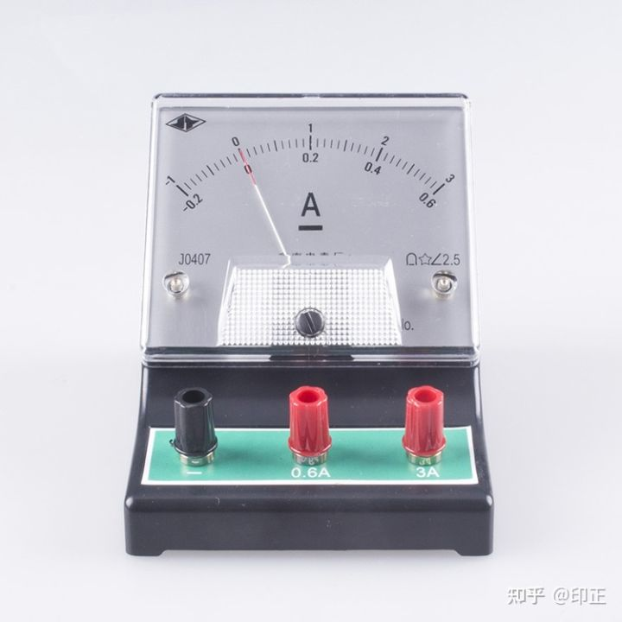电流表/电表/安培表 ammeter

15、A = amp = ampere

安，安培(电流单位，缩略形式为 amp或A)

An ampere is a unit which is used for measuring electric current. The abbreviation amp is also used.  
安培是用来测量电流的单位。缩写amp也被使用。

　　简简单单的字母也可以有大大的用处!可能“言简意赅”说的就是它们了。在日常生活中有一些带有字母的表达，即简单又传神，最主要的是，还容易记住哇，保证你见过一次就会用了!看看下面简单的表达，哪些是你可以用到的吧!

　　A-list = [usually before noun] used to describe the group of people who are considered to be the most famous, successful or important.

　　我们常说的“一线”就是这个表达了，例如：

　　He only invited A-list celebrities to his parties.

　　也可以作为名词使用，表示a list or group of the most admired or desirable people, as for a job or social gathering，例如：

　　It’s a private party for Hollywood’s A list.

　　The boss gave me his A-list of people we should try to recruit.

　　B-list = [usually before noun] used to describe the group of people who are considered to be fairly famous, successful or important, but not as much as the A-list people.

　　既然有A-list，自然就有B-list，例如：

　　a TV chat show full of B-list celebrities

　　Plan A = the thing or things somebody intends to do if everything happens as they expect.

　　情况一切顺利时原有的计划，例如：

　　Shall we go for plan A or plan B?

　　同理，Plan B就是the thing or things somebody intends to do if their first plan is not successful. 有种backup plan的感觉，例如：

　　If Plan A fails, go to Plan B.

　　from A to B = from one place to another

　　从A地到B地，虚指地点，例如：

　　For me a car is just a means of getting from A to B.

　　字母经常用于虚指某人某物或某地，例如：

　　X / Y = a person, a number, an influence, etc. that is not known or not named. 例如：

　　Let’s suppose X knows what Y is doing.

　　A / B = used to represent a person, for example in an imagined situation or to hide their identity. 例如：

　　Assume A knows B is guilty.

　　from A to Z = including everything there is to know about something.

　　所有需要知道的，例如：

　　He knew his subject from A to Z.

　　the big C = an informal name for cancer, any form of cancer.

　　癌症的委婉说法，例如：

　　I thought I just had an iron deficiency or something, but the lab tests showed it was the big C.

　　(推荐一部美剧The Big C《如果还有明天》)

　　with a capital A, B, etc. = used to emphasize that a word has a stronger meaning than usual in a particular situation, or to mean that a particular idea or concept is being understood in only the strictest sense.

　　表示强调某词时使用，或表示所提到的概念是很专业很严肃的情况，例如：

　　He was romantic with a capital R.

　　I am hungry with a capital H! Let’s eat!

　　No, it’s not an emergency with a capital E. I can wait until the end of the day.

　　Well, it’s not literature with a capital L, but it’s still a good story.

　　When he talks about photography, he means with a capital P. He would never think to consider pictures taken on smartphones.

　　to a T / tee = used to say that something is exactly right for somebody, succeeds in doing something in exactly the right way, etc.

　　非常准确完美的完成，某物对某人来说完全适合，例如：

　　Her new job suits her to a T. (= it is perfect for her).

　　You look beautiful. That color really suits you to a tee.

　　The novel captures the feeling of the pre-war period to a T.

　　A-OK = in good condition; in an acceptable manner; operating or existing in perfect working order or in the best condition to be hoped for.

　　一个字-“好!” 例如：

　　The party went off A-OK.

　　I’ve felt A-OK since I left the hospital last week.z

　　So far the new engine is running A-OK!

　　Z’s [pl.] = sleep.

　　漫画里人在睡觉时会标注Zzzz, 所以可以很幽默的用它来表示sleep，例如：

　　I need to catch some Z’s.

　　K = one thousand.

　　在聊薪资的时候，经常会用到，例如：

　　She earns 40K (= £40 000) a year.

　　p.d.q. = pretty damn / damned quick (= very fast)

　　快点儿!跟asap (as soon as possible)感觉挺像，例如：

　　Make sure you get here p.d.q.

　　还有一些我们在平时阅读时会看到，也顺便了解一下吧!例如：

　　n/a = not applicable (used on a form as an answer to a question that does not apply to you)

　　w/o = without

　　i.e. = used to explain exactly what the previous thing that you have mentioned means

　　e.g. = for example

　　etc. = used after a list to show that there are other things that you could have mentioned

B & B = bed and breakfast

Transitive

示例单词fancy <http://www.icooc.com/service/oxford/search/?word=fancy>

**1** [transitive] (British English, informal) to want something or want to do something

**SYNONYM**

**[feel like](http://www.icooc.com/service/oxford/search/?text=feel_1" \o "feel like definition)**

**fancy something** *Fancy a drink?*

*I fancied a change of scene.*

*She didn't fancy*(= did not like)*the idea of going home in the dark.*

**fancy doing something** *Do you fancy going out this evening?*

I am a fond parent to every child of my fancy, and that no one can ever love that family as dearly as I love them。

**Vi** intransitive verb

* (of verbs) used without a direct object

**OPPOSITE**

**[transitive](http://www.icooc.com/service/oxford/search/?text=transitive" \o "transitive definition)***The verb ‘die’ as in ‘He died suddenly’, is intransitive*

* ADJ An **intransitive** verb does not have an object. 不及物的..

1. VAR **Rage** is strong anger that is difficult to control. 盛怒

N-SING

N 是Noun的缩写，表示名词，SING 是 Singular 的缩写，表示单数。所以，N - SING 表示该词的词性为名词的单数形式。

N-PLURAL 名词复数形式。